**SUMMER INTERNSHIP PROJECT REPORT**

**FLUID FLOW IN LUBRICATION LINES**

**DRDO, GTRE**

**GAS TURBINE RESEARCH ESTABLISHMENT**

RSIF, Gearbox Division

*Joe Joseph*

*BTech 5th Semester, Mechanical Engineering*

*Delhi Technological University*

**FLUID FLOW IN LUBRICATION LINES**

**Abstract**

In the housing of an assembly like an engine block, gearbox etc, there are lubrication pipelines that are either cast into the block using a core or by hybrid casting which uses a prefabricated pipeline in the cast. These pipelines may also consist of branched injectors that deliver oil/lubricant at high pressure through a nozzle/orifice to the internal components in the form of a jet with some flow rate depending on the requirement of the component.In this study the theoretically modelling of this problem will be documented.

**Problem Definition**

We will condense the problem into the most basic form and take the most idealistic case and optimise it in various aspects. In this study, we will encounter 5 cases, each one improving upon the assumptions and building on a realistic scenario getting us closer and closer to the experimental data.

Firstly, we will reduce the complex pipeline geometry into a simple form, easy to apply our most generalised concepts and formulae. We will then model this geometric model to get the most optimised solution. Cases 1, 2 and 3 will deal with this problem.

Secondly, we will expand the geometric features its nearly final form and model then problem. To do so, we will again take an idealistic approach and find the solution, then optimise it using the methods and findings from the previous problem to get the final solution of the problem. Cases 4, 5 and 6 will deal with this problem.

Finally, a 7th case will be formulated with a highly optimised minor losses model. In this case, we will assume a handbook data for minor losses and then optimise it using CFD data of this specific problem. The optimisation will be done using a MATLAB program to get the closest possible results.

To start with, we will take the following properties that govern the problem definition. The properties of the lubricating oil, the boundary condition imposed on the pipeline. These are necessary and have to be accurately determined as variations due to temperature or impurities in the oil will cause errors to creep into experimental and final theoretical solution.

NAME: **SAE 30W oil**

|  |  |  |
| --- | --- | --- |
| **Sr.no.** | **Property** | **Value** |
| 1. | Density of oil (ρ) | 891.00 Kg/m3 |
| 2. | Viscosity of oil (µ) | 0.029 N.s/m2 |
| 3. | Temperature (T) | 20°C |
| 4. | Inlet Pressure (P) | 5.0 Kgl/cm2 |
| 5. | Ambient Pressure (P0) | 101325 Pa |

**General Assumptions**

These are some of the general assumptions that need to be considered in all the cases we encounter. As these are beyond the scope of the problem definition, they are given as follows:

* There are absolutely No restrictions in the flow due to bends in the pipe, manufacturing defects in the pipe wall due to casting, threads and flanges at the joints of the pipeline.
* The walls of the pipeline are considered as adiabatic walls with no heat flux between the fluid and the cast block of the assembly casing and also with no rise in the temperature of the fluid due to friction.
* Low Reynolds number flow is taken within the pipeline as turbulence modelling is relatively difficult.
* Gravitational potential energy is neglected as the orientation of the pipe is not known or is not to be accounted for.

**Concepts involved.**

There are three basic differential equations of fluid motion:

Continuity:

Momentum:

Energy:

In this problem we will use certain control volumes to find the necessary parameters by applying the concepts and hence find the required result. The above general equations of fluid motion are condensed in the following manner for our requirement.

1. **Conservation of mass (continuity) Equation:**

In this problem the fluid is considered incompressible and the density does not change due to the motion of the fluid and parameters like pressure and velocity. Due to these assumptions the continuity equation becomes:

Where,

Q is the Flow rate,

A is the cross sectional area of the pipe, given by

V is the velocity of the fluid in the given cross section.

**______________________ (A)**

Where,

, ,

V0 is the Fluid velocity of the inlet.

A0 is the Area cross section of the inlet pipe.

V1,V2& V3 are the Fluid jet velocities.

A1,A2& A3 are the Area cross section of the nozzles/orifices.

1. **Bernoulli’s Equation**

Closely related to the steady-flow energy equation is a relation between pressure, velocity, and elevation in a frictionless flow, now called the Bernoulli equation, is a very famous and most widely used. It is a powerful formula used in problems pertaining to hydrodynamics.

**______________________ (B)**

Where,

P is the Static pressure of the fluid,

V is the Flow velocity of the fluid,

Z is the elevation from a reference

g is the acceleration due to gravity,

ρ is the density of the fluid.

The only restrictions of this formula it holds true only for a steady incompressible frictionless flow. The control volume for solving this has to be taken as such it follows this restriction in mind. Further improvement on Bernoulli’s equation has helped use this formula in cases of viscous or frictional flow as will be seen ahead as we tackle the problem.

**Diagram& Dimensions**

Ø

Ø

Ø

Ø

|  |  |  |
| --- | --- | --- |
| **Sr. no.** | **Dimension** | **Value (m)** |
| 1. | Pipe Diameter (D0) | 0.004 |
| 2. | Jet 1 Diameter (D1) | 0.000283 |
| 3. | Jet 2 Diameter (D2) | 0.00048 |
| 4. | Jet 3 Diameter (D3) | 0.00114 |
| 5. | Jet 1 from inlet (L1) | 0.05 |
| 6. | Jet 2 from jet 1 (L2) | 0.05 |
| 7. | Jet 3 from jet 2 (L3) | 0.05 |

**CASE 1: Ideal Flow**

In this case we take the following assumptions:

* The fluid flow is steady and incompressible meaning the inlet conditions are not transient and a constant flow field is set up and the density of the fluid also does not change.
* Laminar with an inviscid fluid flow, viscosity of the fluid is not considered.
* No Frictional Head losses are considered due to the velocity gradient formed along the normal cross sectional area of the pipe due to no-slip at walls.
* Negligible Minor Losses (Due to sudden contraction and sudden expansion)

In this case, we are given 3 jets in the pipeline which are merely 3 orifices on the pipe. We consider a control volume at the exit region of each orifice.

If we consider 2 points, one within the pipe and one outside the pipe, we can conserve the total pressure heads between these two points. The Bernoulli’s Equation transforms to:

**_____________________ (1.1)**

**Fluid Flow**

**V0**

**V0**

1

**Pipe Wall**

**Control Volume**

2

**V1**

**Jet**

In equation (1.1), only the static pressure head of the point in the pipe is taken. The static head, which is the ambient pressure of the outlet as well as dynamic head which translates to the jet velocity of the point outside the pipe are taken. By rearranging the terms in equation (1.1) we get:

Similarly,

**____________________ (1.2)**

**____________________ (1.3)**

**____________________ (1.4)**

After substituting the values in the above equations (1.2), (1.3) and (1.4) we get the velocities of the jets. We now use the continuity equation to find the discharge or the Flow rates. The inlet velocity can also be computed using equation (A) once we have all the jet velocities.

**CASE 2: Laminar Viscous Flow**

Now, if we consider the major head losses, which are predominantly the viscous frictional forces that cause a loss in the pressure head of the flow between 2 points in a pipe. These head losses are given by the modifying the Bernoulli’s equation (B) which gives us:

**__________________ (2.1)**

Where,

hLis the head losses (also known as Major losses)

z1, z2 are the datum points for the gravitational potential energy,



**Laminar Flow in a pipe**

Now the assumptions that have to be considered while modelling the problem with Head lossin a laminar viscous flow are:

* There is a no- slip condition at the boundary walls of the pipeline,
* The surface roughness is neglected due to this,
* The flow is fully set up and no variations in the inlet conditions,
* The flow regimes at the sharp edges of the orifices are also not considered in the calculations.

Taking the above assumptions the head losses due to the viscous friction are taken as:

Where,

**____________________ (2.2)**

f is the friction factor,

L is the length of the pipe taken

D is the diameter of the pipe only for a circular pipe.

Darcy’s Friction factor:

For the above assumptions, is was found that the frictional factor of the Major head losses in a laminar flow with no-slip at the boundary walls is:

Hence substituting the valve of this friction factor in equation (2.2), the head losses are given as:

**______________________ (2.3)**

If we consider 2 points, one within the pipe and one outside the pipe, we can conserve the total pressure heads between these two points. Here, only the static pressure head of the point in the pipe is taken. The static head, which is the ambient pressure of the outlet as well as dynamic head which translates to the jet velocity of the point outside the pipe are taken along with the head losses experienced by the fluid in the section of the pipe between the inlet and the first jet. By rearranging the terms in and substituting the values from equation (2.3) into the modified Bernoulli’s equation (2.1) we get:

**_____________________ (2.4)**

Similarly, we take another 2 points at the next orifice and so on, using the same assumption we equate the static pressure heads and the dynamic heads along with the losses experienced by the fluid before this orifice.

**____________________ (2.5)**

**____________________ (2.6)**

Where,

And from the equation of continuity we have the relation:

**___________________ (Ref A)**

**Solution**

The Equations (2.4), (2.5) and (2.6) are interdependent and form an explicit relationship given by the equation (A). To solve for these variables, Numerical Methods have to be employed. In these methods the variables are initialised with a rough solution and then the conditions of interdependence are imposed on it and iterated forward till the convergence criteria is not met which is given by.

**______________________ (C)**

Where,

Vi is the ith jet velocity,

n is the number of iterations completed

The relative closeness to zero is a set value and can be specified depending on the required significant figures in the final solution of the values of the velocities. In this study, values of up to 6 decimal places are taken as significant.

For initialising the variables, we take the following assumption.

**_____________________ (2.7)**

And we have,

Finding the roots of this quadratic equation, we get:

**_________________ (2.8)**

Similarly, we assume,

And we have,

**_________________ (2.9)**

Similarly, we get,

**________________ (2.10)**

We neglect the negative roots of the quadratic equations as they represent no great significance since the inlet pressure is always more than the outlet pressure, hence flow reversal in not possible.

Now with these initial valves for V1, V2, & V3 from the equations (2.8), (2.9) and (2.10) we obtain a value for V0. After substituting the values into equation (A) and getting the new inlet velocity, the second Iteration is done by using the equations (2.4) (2.5) & (2.6) are used to compute the new value of V0. This Iteration process is continued till the convergence criteria given in equation (C) is not met.

**Flow chart 1**

A neat visual representation of the process of computation is depicted below in the form of a flow chart. This depicts the control flow of a computer software program to iterate the equations in a loop to find the final solution of the variables.

**Initialising**

eq. (2.8), (2.9) & (2.10)

**New V0**eq. (A)

**New V1 V2 V3**eq. (2.4) (2.5) & (2.6)

**No**

**Yes**

**Check convergence**

**Final Solution**

**V0V1 V2 V3**

**CASE 3: Optimised Laminar Viscous Flow**

Optimising the above model we look at the shortcomings Faced by it. These shortcomings with their explanations are listed below.

* The head losses after the first jet are computed wrongly as the velocity within the pipe after the first jet is not as same as the inlet velocity. This means velocity should be lower in the sections after the first jet; hence the head losses computed from the model are much higher and have to be optimised to get the correct values.
* The iteration cycle in the model computes the jet velocities and then calculated the new inlet velocity, this increases computational time and power. Reducing the cycles and reaching a converged result quicker can be done by substituting the new jet velocities computed into a new inlet velocity. All variables do not converge at the same time but this reaches convergence relatively quicker.

The first jet will have the same equation as the previous case:

**_________________ (Ref 2.4)**

Now, the velocity of the fluid within the pipe after the first jet (taken as V’) can be computed by the following equation, which is derived from the continuity equation:

**_________________ (3.1)**

Using the similar approach as for finding equation (10), we find the velocities at the consecutive jets by considering head losses in the sections after the jet separately. It is given by:

**_________________ (3.2)**

Similarly,

**_____ (3.3)**

Where,

**Fluid Flow**

**V’**

**V’’**

**V0**

3

2

1

**Pipe Wall**

3’

1’

2’

**V3**

**V2**

**V1**

**Jet 3**

**Jet 2**

**Jet 1**

**Solution**

For initialisingthe variables we take the following assumption:

We now use the above equations (ref 10) and substitute the values in terms of V1 and form the quadratic equation given below:

Finding the roots of this quadratic equation we get the value of V1, like in the previous case we will discard the negative root as this value is of no significance.

**_____________ (Ref 2.8)**

Similarly,

For initialising the next variable we take the following assumption:

This improved assumption is taken to converge to the solution quicker, reducing number of iteration and computational time, as the computed value of V1 which was initialised is incorporated into the continuity equation (ref 1) which is met in the iteration process. Computing a much this refined initial valve of the variable results in quicker convergence.

Similarly, we finding the roots of this quadratic equation we get the value of V2

**____ (3.4)**

Similarly, we take an improved assumption and evaluate the value of V3

**(3.5)**

**Flow chart 2**

This flow chart visually depicts the control flow of a computer software program to iterate the equations in a loop to find the final solution of the variables.

**Initialising**

eq. (2.8), (3.4) & (3.5)

**New V0**eq. (A)

**New V1 V2 V3**eq. (2.4) (3.2) & (3.3)

**Final Solution**

**V0V1 V2 V3**

**Yes**

**No**

**Check convergence**

**CASE 4: Improved geometric model (with injector branches)**

Now since from the previous case we have modelled the problem relatively close to the most theoretical approach, we need to add features to the lubrication line to bring it closer to the real part. To do so, we add branches in the pipe which act as the injector supply pipe. These branches direct the jet of lubricant oil directly onto the component that is required to be lubricated. The nozzles/orifices are made at the ends of these branches which finally deliver the oil in the form of a jet.

Branching is done in the pipeline because this increases the jet dischargeas the nozzle/orifice will experience the static as well as dynamic pressure head of the fluid flow in the pipe. This additional dynamic head increases the jet discharge, which will also be computed and validated by the results of these cases.

In this case, we will take an ideal flow for this geometric model and not consider any major losses due to viscous flow and minor losses due to sudden contraction or bends in the pipe.

**Diagram & Dimensions**

Ø

Ø

Ø

Ø

Ø

Ø

Ø

|  |  |  |
| --- | --- | --- |
| **Sr. No.** | **Dimension** | **Value (m)** |
| 1. | Jet 1 Branch Diameter (D’1) | 0.001 |
| 2. | Jet 2 Branch Diameter (D’2) | 0.002 |
| 3. | Jet 3 Branch Diameter (D’3) | 0.003 |
| 4. | Jet 1 Branch Length (L’1) | 0.05 |
| 5. | Jet 2 Branch Length (L’2) | 0.05 |
| 6. | Jet 3 Branch Length (L’3) | 0.05 |

**Solution**

To solve this new model we will assume all the general assumptions and the assumptions taken in the Ideal flow in case 1.

If we take the major pipeline that transports the lubricant to the branches as the control volume, we apply the concept of mass conservation or continuity to get the velocities of the fluid in the branches. The equations are given as follows:

**_________________ (4.1)**

Where,

, ,

Now, similarly if we take any one branch and apply the same concept of continuity, we get the following relation from the equation (1) and (). This relation is true in all the branches. The relations are:

**_________________ (4.2)**

**_________________ (4.4)**

**_________________ (4.3)**

Now, if we take a control volume at the orifice, such that half volume is exists within the branch and the rest outside where the jet is formed. We apply Bernoulli’s equation by equating the total pressure heads on both regions; inside and outside the branch. The equation thus formed is:

Rearranging the terms in the equation, we get:

Using, the relation given above and substituting the value of V’1 in terms of V1, we get:

**_________________ (4.5)**

Similarly,

**___________ (4.6)**

**___________ (4.7)**

**CASE 5: Laminar Viscous Flow 2 (with Major losses)**

Refer to Case 6 and take *K* (loss coefficient) of minor losses as zero.

**CASE 6: Realistic Scenario (Major and Minor losses)**

Optimising the above model we look at the shortcomings Faced by it. These shortcomings with their explanations are listed below.

* The Major losses, due to the viscous friction forces in a laminar fluid flow are not considered. These losses arise due to the no-slip condition that have to be imposed on the fluid flow to obtain a parabolic velocity profile in the cross section of the pipe with a linear radial shearing force on the fluid motion. This causes the pressure of the fluid to gradually reduce along the length of the pipe, this loss is known as the Major Head losses.
* The Minor losses, due to the sudden contraction or bends in pipes are not considered. These losses arise in branching occurs due to the sudden change in area which cause the formation of a vena contracta at the branch inlet, reducing the effective area of the branch hence reducing the total Pressure head. Whereas in bends it occurs due to flow separation at the walls and a swirling secondary flow arising from the centripetal acceleration.

Bernoulli’s equation from (B) and (2.1) becomes the following for a general case considering the major as well as the minor losses becomes:

Where,

**_________________ (5.1)**

Minor head losses are defined as:

Where,

*K* is the known as the loss Coefficient or Resistance Coefficient. It will be taken as ‘m’ in the formulas, for ease in understanding.

This constant of the minor losses are determined experimentally and tabulated by the manufacturer with each component, like an elbow joint (with different angles and diameters), Tee joints, valves etc.

Now, we take the junction in the pipe where the branching occurs. In this region we take a control volume as shown in the figure an apply Bernoulli’s equation, we get:

**Junction**

**V’**

**V0**

**Section 2**

**Section 1**

**Fluid Flow**

**V’1**

**Pipe wall**

**Jet 1**

Rearranging the terms and Assuming:, since the static pressure at section 1 in the pipe will be the same as the branch with the pressure head and the minor losses taken into account.

Where, *K1*is the loss coefficient at the jet 1 branch inlet.

**_________________ (5.2)**

Similarly, we apply the same concept at the second junction that is the intersection of section 2, 3 and jet 2 branch, we get:

Like in the previous laminar flow case we have taken the flow at the different sections using continuity. Now rearranging the terms and Assuming: , we get:

**_________________ (5.3)**

Similarly for the third junction where the sections 3 and jet 3 branch meet, we have:

Assuming:

**_________________ (5.4)**

Now, at the Nozzle/Orifice of the injector, we apply Bernoulli’s equation considering all the head losses that the fluid has experienced so far along the pipeline. We get:

**V’1**

**Fluid Flow**

**Branch wall**

**Control Volume**

**V1**

**Jet**

Where,

These head losses can be easily evaluated using the concepts given earlierfor the major head losses and the minor losses.

Substituting the value of the head losses in the Bernoulli’s equation and rearranging the terms, we get:

Rearranging the variables in terms of V1, we get:

**_________________ (5.5)**

Similarly for the jet 2 we apply the same concept, the head losses of this jet will be given as:

Substituting the value of the head losses in the Bernoulli’s equation and rearranging the terms, we get:

**____________ (5.6)**

Similarly for the jet 3 we apply the same concept, the head losses of this jet will be given as:

Substituting the value of the head losses in the Bernoulli’s equation and rearranging the terms, we get:

**(5.7)**

**Solution**

To initialise the above equations we need to make an assumption to find a rough value for the velocity. As in the previous cases we take the following assumption:

From the previous case we know that:

Substituting these relations in equation (5.5), we get a quadratic equation in V1, this quadratic can be written as:

Similarly,

For initialising the next variable we take the use the concept learnt from the previous cases regarding optimised solution and quicker iteration. Hence we make the following assumption:

We know that:

Substituting these relations in equation (5.6), we get a quadratic equation in V2, this quadratic can be written as:

Similarly,

We know that:

Substituting these relations in equation (5.7), we get a quadratic equation in V2, this quadratic can be written as:

**Flow chart 3**

This flow chart visually depicts the control flow of a computer software program to iterate the equations in a loop to find the final solution of the variables.

**Initialising**

eq. (5.8), (5.9) & (5.10)

**New V0**eq. (A)

**New V’1 V’2 V’3**eq. (5.2) (5.3) & (5.4)

**New V1 V2 V3**eq. (5.5) (5.6) & (5.7)

**No**

**Final Solution**

**V0V1 V2 V3**

**Yes**

**Check convergence**

**CASE 7: Optimised Minor losses**

Optimising the above model we look at the shortcomings Faced by it. These shortcomings with their explanations are listed below.

* The Minor losses, which consist of the resistance coefficient was only dependent on the geometry of the pipeline. Optimising this into a new generalised formula was deduced to match our requirement, after extensive research on the literature of the same, and referring piping system handbooks

This formula was given as:

**_________________ (7.1)**

And

**_________________ (7.2)**

According to the Handbook, these are the ranges given for the constants in the above formula. Since these are generalised constants for piping systems with flanges, threads, and varying radii.

|  |  |  |
| --- | --- | --- |
| **Flow Region** | ***K1*** | ***Kf*** |
| Branched flow | 500-1000 | 0.7-1.0 |
| In-line flow | 100-200 | 0-1.1 |
| Exit Flow | 0-160 | 0.5-1 |

For, better optimising, we will not limit the ranges to the above values while performingsimulation, but an extension of this range will be taken by 50% more and less at upper and lower limits respectively. The resulting range will be

|  |  |  |
| --- | --- | --- |
| **Flow Region** | ***K1*** | ***Kf*** |
| Branched flow | 250-1250 | 0.4-1.3 |
| In-line flow | 50-250 | 0-1.65 |
| Exit Flow | 0-240 | 0-1.5 |

Now, from equation (7.1) and (7.2):

Now for the various regions that minor losses occur, we list the minor loss coefficients,

* At the exits (jets): equations (7.2a,b,c)

* At the branches (tees): equations (7.1 a,b,c)

Where,

* At the junctions (in line): equations (7.1 d,e)

Where,

We will firstly verify these coefficients using CFD on ANSYS FLUENT 15.0, by comparing the head losses at various interfaces to validate our results. The data will be plotted in the results section

Now, we take the junction in the pipe where the branching occurs. In this region we take a control volume as shown in the figure an apply Bernoulli’s equation, we get:

Rearranging the terms and Assuming: , since the static pressure at section 1 in the pipe will be the same as the branch with the pressure head and the minor losses taken into account.

Where, *K1*is the loss coefficient at the jet 1 branch inlet.

Similarly, we apply the same concept at the second junction that is the intersection of section 2, 3 and jet 2 branch, we get:

**_________________ (7.3)**

Like in the previous laminar flow case we have taken the flow at the different sections using continuity. Now rearranging the terms and Assuming:, we get:

**_________________ (7.4)**

Similarly for the third junction where the sections 3 and jet 3 branch meet, we have:

Assuming:

**_________________ (7.5)**

Now, at the Nozzle/Orifice of the injector, we apply Bernoulli’s equation considering all the head losses that the fluid has experienced so far along the pipeline. We get:

Where,

These head losses can be easily evaluated using the concepts given earlier for the major head losses and the minor losses.

Substituting the value of the head losses in the Bernoulli’s equation and rearranging the terms, we get:

Rearranging the variables in terms of V1, we get:

**_________________ (7.6)**

Similarly for the jet 2 we apply the same concept, the head losses of this jet will be given as:

Substituting the value of the head losses in the Bernoulli’s equation and rearranging the terms, we get:

**___ (7.7)**

Similarly for the jet 3 we apply the same concept, the head losses of this jet will be given as:

Substituting the value of the head losses in the Bernoulli’s equation and rearranging the terms, we get:

**__ (7.8)**

**Solution**

To initialise the above equations we need to make an assumption to find a rough value for the velocity. As in the previous cases we take the following assumption:

From the previous case we know that:

Substituting these relations in equation (5.5), we get a quadratic equation in V1, this quadratic can be written as:

**__ (7.9)**

Similarly,

For initialising the next variable we take the use the concept learnt from the previous cases regarding optimised solution and quicker iteration. Hence we make the following assumption:

We know that:

Substituting these relations in equation (5.6), we get a quadratic equation in V2, this quadratic can be written as:

**__ (7.10)**

Similarly,

We know that:

Substituting these relations in equation (5.7), we get a quadratic equation in V3, this quadratic can be written as:

**__ (7.11)**

**Flow chart 4**

This flow chart visually depicts the control flow of a computer software program to iterate the equations in a loop to find the final solution of the variables.

**Initialising**

eq. (7.9), (7.10) & (5.10)

**New V0**eq. (A)

**New V’1 V’2 V’3**eq. (7.3) (7.4) & (7.5)

**New *mf1mf2 mf3 m’f1 m’f2 m’f3 m”f1 m”f3*** eq. (7.1 a,b,c,d,e,f) (7.2 a,b,c)

**New V1 V2 V3**eq. (7.6) (7.7) & (7.8)

**Check convergence**

**Yes**

**No**

**Final Solution**

**V0V1 V2 V3**

**CASE 8: Optimised Iteration**

Optimising the above method of iteration we look at the shortcomings Faced by it. These shortcomings with their explanations are listed below.

* The above method gives inaccurate results and is highly dependent on the initial value of the variables taken.
* The iteration takes a high number of cycles to converge and is not suited for computing.

These shortcomings can be dealt with but making some changes to the formulas used in the iteration process.

We proceed with the definitions of all the variables and the equations

At the Branches:

**_________ (8.1)**

Similarly, at branch 2

**_________ (8.2)**

At branch 3

**_________ (8.3)**

Now at the jets:

**___________ (8.4)**

Similarly,

**____________ (8.5)**

And

**_________________ (8.6)**

**Solution**

Using the equations (8.1) (8.2)(8.3). Since they are quadratic equations for particular variables we will find the roots of those variables in terms of the other variables. We get:

Similarly,

Using the equations (8.4) (8.5)(8.6). Since they are quadratic equations for particular variables we will find the roots of those variables in terms of the other variables. We get:

Similarly, for the other equations we have,

**Analytical Solutions**

Now that we have successfully modelled our problem in the form for a program, we will change the operating parameters (or variables) to get the necessary solution for different conditions.

**Invisicd**

In this condition, we will assume the oil has no viscous properties; hence the head losses due to this property will be nullified. To do this we will take the viscosity of the oil to be zero. Doing so we reduce the Major losses to zero and also reduce the Minor losses by a certain amount, this gives us the solution which is independent of the viscosity of the fluid.

**Viscous free-slip**

In this condition, we assume that there is free slipping of fluid at the walls of the pipe, this means that there is no shearing of the fluid as it flows in the pipe. To do this we take the Major Loss constants (taken in the equations) to be zero. The minor losses are unaffected as the viscosity of the fluid is not assumed to be zero.

**Laminar**

In this condition, we take the realistic conditions. We assume that the fluid is viscous and there is no slipping at the walls of the pipe. This causes shearing of the fluid and imparts a parabolic velocity profile to the fluid flow. At the junctions and jets we have minor losses due to sudden contractions and bends which cause hindrance in the fluid flow.

**MATLAB**

MATLAB® & Simulink® are the premier software packages for technical computation, data analysis, and visualization in education and industry. In this study we used this engineering problem solving package to find the solution of this problem.

**Newton-Raphson**

The method used to sol this problem is Newton-Raphson. The Newton–Raphson algorithm is the best-known method of finding roots for agood reason: it is simple and fast.The only drawback of the method is that it uses the derivative f’(x) of the function as well as the function f(x) itself. Therefore, Newton-Raphson method is usable only in problems where f’(x) can be readily computed.

In order to derive the Newton–Raphson method for a system of equations, we startwith the Taylor series expansion of fi (x) about the point x:

Dropping terms of order Δx2, we can write

Where, J(x) is the Jacobian matrix (of size n ×n)made up of the partial derivatives

Note this is a linear approximation (vector Δx being the variable) of thevector-valued function f in the vicinity of point x.

Let us now assume that x is the current approximation of the solution off(x) = 0, and let x + Δx be the improved solution. To find the correction Δx, we setf(x + Δx) = 0 in Eq. (4.5b). The result is a set of linear equations for Δx:

The following steps constitute Newton–Raphson method for simultaneous, nonlinearequations:

1. Estimate the solution vector x.

2. Evaluate f(x).

3. Compute the Jacobian matrix J(x) from Eq. (4.6).

4. Set up the simultaneous equations in Eq. (4.7) and solve for Δx.

5. Let x ← x + Δx and repeat steps 2–5.

The above process is continued until |Δx| < ε, where ε is the error tolerance. Asin the one-dimensional case, success of the Newton–Raphson procedure dependsentirely on the initial estimate of x. If a good starting point is used, convergence tothe solution is very rapid. Otherwise, the results are unpredictable.

For the given problem we will take the equations from the optimised Iteration (case 8) as the non linear equations. They are equations

The following script was written in MATLAB and was run in the workspace by typing the script name in the command prompt.

The required variables in the workspace with their names and values are given as follows:

1. **oil**

|  |
| --- |
| 891 |
| 0.0290000000000000 |

1. **Dia**

|  |
| --- |
| 0.00400000000000000 |
| 0.000283000000000000 |
| 0.000480000000000000 |
| 0.00114000000000000 |
| 0.00100000000000000 |
| 0.00200000000000000 |
| 0.00300000000000000 |

1. **length**

|  |
| --- |
| 0.0500000000000000 |
| 0.0500000000000000 |
| 0.0500000000000000 |
| 0.0500000000000000 |
| 0.0500000000000000 |
| 0.0500000000000000 |
| 0.0500000000000000 |

1. **Pressure**

|  |
| --- |
| 5 |
| *(pressure in psi) |
| *(pressure in Pascal) |
| 101325 |
| * |

*Not necessary to substitute, but mandatory to allocate memory.

1. **minor**

|  |  |
| --- | --- |
| 160 | 1 |
| 500 | 0.700000000000000 |
| 200 | 1.10000000000000 |

**MATLAB CODE (named New.m)**

Area =pi*Dia.^2./4;

AreaR=Area(2:7,1)./Area(1,1);

Major=64*oil(2,1)/oil(1,1).*length(1:3,1)./(Dia(1,1)^2);

Major(4:6,1)=64*oil(2,1)/oil(1,1).*length(4:6,1)./(Dia(5:7,1).^2);

Pressure(2,1)=Pressure(1,1)*(30.48/12)^2/0.4536;

Pressure(3,1)=Pressure(1,1)*(30.48/12)^2/0.4536*6895;

Pressure(5,1)=2*(Pressure(3,1)-Pressure(4,1))/oil(1,1);

minor=[160 1 ;500 0.7 ;200 1.1 ];

K(1:3,1)=(minor(1,1)*oil(2,1)/oil(1,1))./Dia(2:4);

K(1:3,2)=minor(1,2);

K(4:6,1)=(minor(2,1)*oil(2,1)/oil(1,1))./Dia(5:7);

K(4:6,2)=minor(2,2)*(1+0.0254/Dia(1));

K(7:8,1)=minor(3,1)*oil(2,1)/(oil(1,1)*Dia(1));

K(7:8,2)=minor(3,2)*(1+0.0254/Dia(1));

Velocity(1:7,1)=5;

Velocity0=zeros(7,1);

i=1;

while (abs(Velocity0-Velocity)>=0.000000001)

Velocity0=Velocity;

V = sym('V', [7 1]);

f(1,1)=V(1)-AreaR(1)*V(5)- AreaR(2)*V(6)-AreaR(3)*V(7);

f(2,1)=(1+K(4,2))*V(2)^2+K(4,1)*V(2)- V(1)^2;

f(3,1)=(1+K(5,2))*V(3)^2+K(5,1)*V(3)-(V(1)-AreaR(4)*V(2))^2;

f(4,1)=(1+K(6,2))*V(4)^2+K(6,1)*V(4)-(V(1)-AreaR(4)*V(2)-AreaR(5)*V(3))^2;

f(5,1)=(1+K(1,1)/V(5)+K(1,2))*V(5)^2+Major(1)*V(1)+Major(4)*V(2)-V(2)^2-Pressure(5);

f(6,1)=(1+K(2,1)/V(6)+K(2,2))*V(6)^2+Major(1)*V(1)+Major(2)*(V(1)-AreaR(1)*V(5))...

+Major(5)*V(3)+(K(7,1)/(V(1)-AreaR(4)*V(2))+K(7,2))*(V(1)-AreaR(1)*V(5))^2-V(3)^2-Pressure(5);

f(7,1)=(1+K(3,1)/V(7)+K(3,2))*V(7)^2+Major(1)*V(1)+Major(2)*(V(1)-AreaR(1)*V(5))...

+Major(3)*(V(1)-AreaR(1)*V(5)-AreaR(2)*V(6))+Major(6)*V(4)+(K(7,1)/(V(1)-AreaR(1)*V(5))...

+K(7,2))*(V(1)-AreaR(1)*V(5))^2+(K(8,1)/(V(1)-AreaR(1)*V(5)-AreaR(2)*V(6))+K(8,2))*(V(1)-AreaR(1)*V(5)-AreaR(2)*V(6))^2-V(4)^2-Pressure(5);

j=jacobian(f,V);

F=subs(f,V,Velocity);

J=subs(j,V,Velocity);

Velocity=J\-F+Velocity0;

i=i+1;

end

**Optimised Iteration in MATLAB (named excel.m)**

Area =pi*Dia.^2./4;

AreaR=Area(2:7,1)./Area(1,1);

Major=64*oil(2,1)/oil(1,1).*length(1:3,1)./(Dia(1,1)^2);

Major(4:6,1)=64*oil(2,1)/oil(1,1).*length(4:6,1)./(Dia(5:7,1).^2);

Pressure(2,1)=Pressure(1,1)*(30.48/12)^2/0.4536;

Pressure(3,1)=Pressure(1,1)*(30.48/12)^2/0.4536*6895;

Pressure(5,1)=2*(Pressure(3,1)-Pressure(4,1))/oil(1,1);

K(1:3,1)=(minor(1,1)*oil(2,1)/oil(1,1))./Dia(2:4);

K(1:3,2)=minor(1,2);

K(4:6,1)=(minor(2,1)*oil(2,1)/oil(1,1))./Dia(5:7);

K(4:6,2)=minor(2,2)*(1+0.0254/Dia(1));

K(7:8,1)=minor(3,1)*oil(2,1)/(oil(1,1)*Dia(1));

K(7:8,2)=minor(3,2)*(1+0.0254/Dia(1));

V0(1:7,1)=5;

V1=ones(7,1)*1;

i=2; %iteration counter

while (abs(V0-V1)>=0.000000001)

V0=V1;

V1(5)=(-K(1,1)+(K(1,1)^2-4*(Major(1)*V0(1)+Major(4)*V0(2)-V0(2)^2-Pressure(5))*(1+K(1,2)))^0.5)/(2*(1+K(1,2)));

V1(6)=(-K(2,1)+(K(2,1)^2-4*(Major(1)*V0(1)+(Major(2)+K(7,1)+K(7,2)*(V0(1)-AreaR(1)*V0(5)))*(V0(1)-AreaR(1)*V0(5))+Major(5)*V0(3)-V0(3)^2-Pressure(5))*(1+K(2,2)))^0.5)/(2*(1+K(2,2)));

V1(7)=(-K(3,1)+(K(3,1)^2-4*(Major(1)*V0(1)+(Major(2)+K(7,1)+K(7,2)*(V0(1)-AreaR(1)*V0(5)))*(V0(1)-AreaR(1)*V0(5))+(Major(3)+K(8,1)+K(8,2)*(V0(1)-AreaR(1)*V0(5)-AreaR(2)*V0(6)))*(V0(1)-AreaR(1)*V0(5)-AreaR(2)*V0(6))+Major(6)*V0(4)-V0(4)^2-Pressure(5))*(1+K(3,2)))^0.5)/(2*(1+K(3,2)));

V1(1)=AreaR(1)*V1(5)+ AreaR(2)*V1(6)+AreaR(3)*V1(7);

V1(2)=(-K(4,1)+(K(4,1)^2+4*V1(1)^2*(1+K(4,2)))^0.5)/(2*(1+K(4,2)));

V1(3)=(-K(5,1)+(K(5,1)^2+4*(V1(1)-AreaR(1)*V1(5))^2*(1+K(5,2)))^0.5)/(2*(1+K(5,2)));

V1(4)=(-K(6,1)+(K(6,1)^2+4*(V1(1)-AreaR(1)*V1(5)-AreaR(2)*V1(6))^2*(1+K(6,2)))^0.5)/(2*(1+K(6,2)));

i=i+1;

end

**CFD**

Computational fluid dynamics is a powerful tool in the analysis of fluid flow for complex geometric models. ANSYS FLUENT 15.0 was used in this study to run the simulations and find the solution for the model.

**Solid works 2015 (CAD)**

The 3D geometry was created as given below with different solid parts like the pipelines, junctions, branches and jets, making a total of 12 solid bodies in the one part, which are listed as follows:

* Pipe 1
* Pipe 2
* Pipe 3
* Branch 1
* Branch 2
* Branch 3
* Junction 1
* Junction 2
* Junction 3
* Jet 1
* Jet 2
* Jet 3

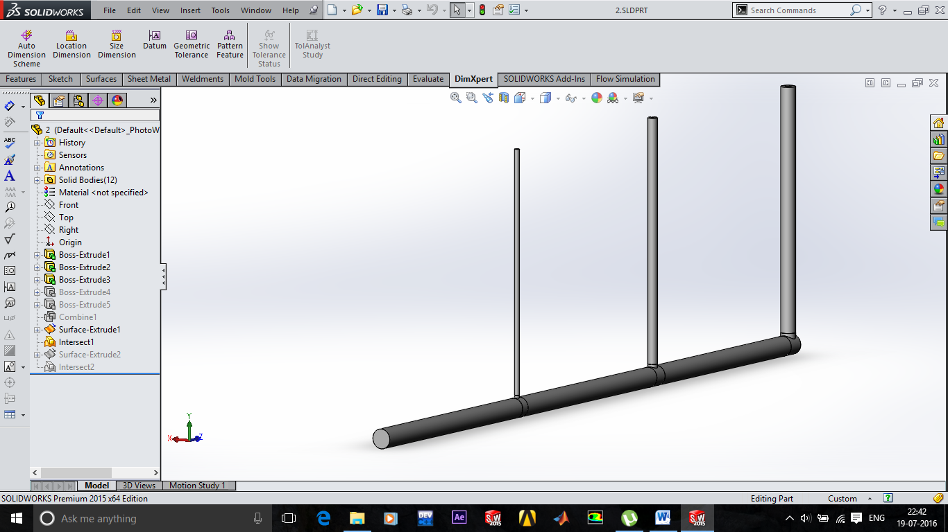

Screenshot of the model being generated in Solidworks: Computer Aided Designing software.

**ANSYS Workbench 15.0**

This was modelled in Solid works 2015 and the sections were created using surfaces that cut the solid into the various sections. This part was then imported into ANSYS Design Modeller in the parasolid .x_t format.

After the model was imported into the workbench of ANSYS the ANSYS Meshing Tool was used to create the mesh.

To make the process simple, the model was divided into 4 similar parts to generate the mesh, they are as follows:

* Pipes
* Branches
* Junctions
* Jets

**ANSYS Mesh Tool**

The various mesh control features added to various parts are as follows:

The pipes, branches and the jets being cylinders were given the same control features but with difference values in its scaling. The values with the features are tabulated below: (values in m)

|  |  |  |  |
| --- | --- | --- | --- |
| **Feature** | **Part** | | |
| Pipe | Branch | Jet |
| Face sizing on base | 0.00001 | 0.00001 | 0.0000001 |
| Face sizing on curvature | 0.0001 | 0.0001 | 0.00001 |
| Inflation size | 0.0000075 | 0.000005 | 0.000001 |
| Inflation layers | 10 | 10 | 10 |

To define the properties of various Boundary conditions, certain named selections had to be made. The various named selection with their respective descriptions are tabulated below:

|  |  |
| --- | --- |
| **Name** | **Description** |
| inlet | Inlet |
| p1_out | Pipe 1 out |
| p2_in | Pipe 2in |
| p2_out | Pipe 2 out |
| p3_in | Pipe 3 in |
| p3_out | Pipe 3 out |
| j1_in | Junction 1 in |
| j1_out | Junction 1 out |
| j2_in | Junction 2 in |
| j2_out | Junction 2 out |
| j3_in | Junction 3in |
| b1_in | Junction 1 to Branch 1 |
| b2_in | Junction 2 to Branch 2 |
| b3_in | Junction 3 to Branch 3 |
| h1_in | Branch 1 in |
| h1_out | Branch 1 out |
| h2_in | Branch 2 in |
| h2_out | Branch 2 out |
| h3_in | Branch 3 in |
| h3_out | Branch 3 out |
| Jet_1_in | - |
| Jet_1_out | - |
| Jet_2_in | - |
| Jet_2_out | - |
| Jet_3_in | - |
| Jet_3_out | - |
| Pipe Walls | All curved surfaces on the body, which represent the walls of the pipeline |

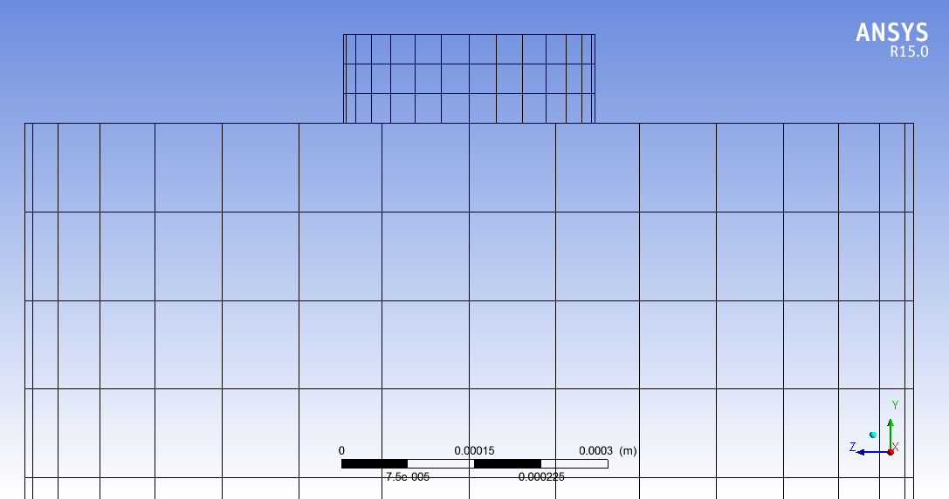

Screenshot of Mesh cross section at the nozzlejet.

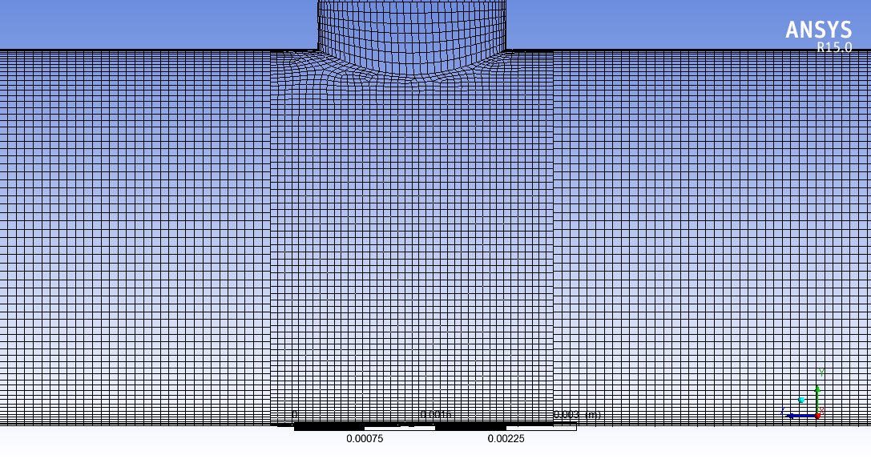

Mesh cross section at Branch of jet

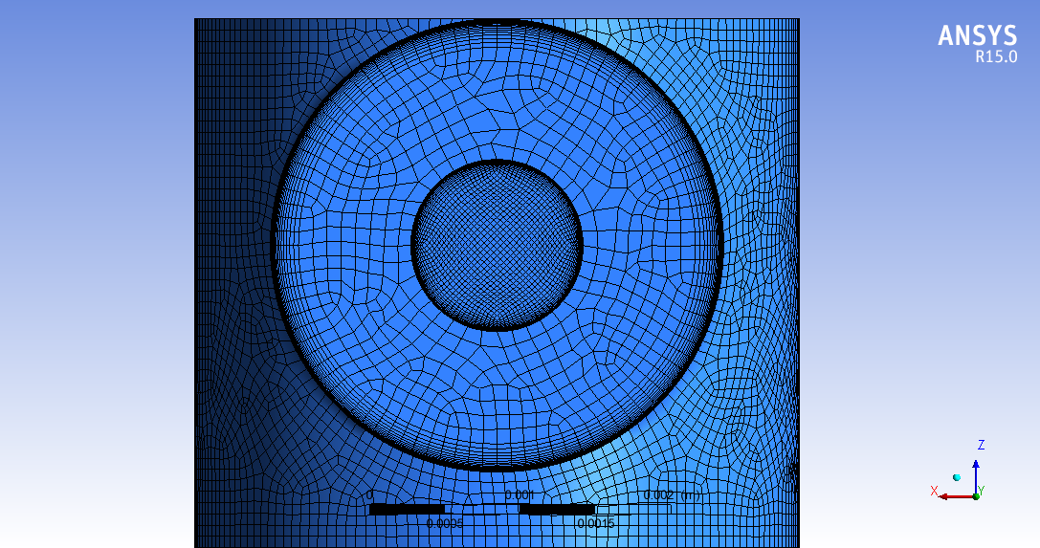

Top View of nozzle jet

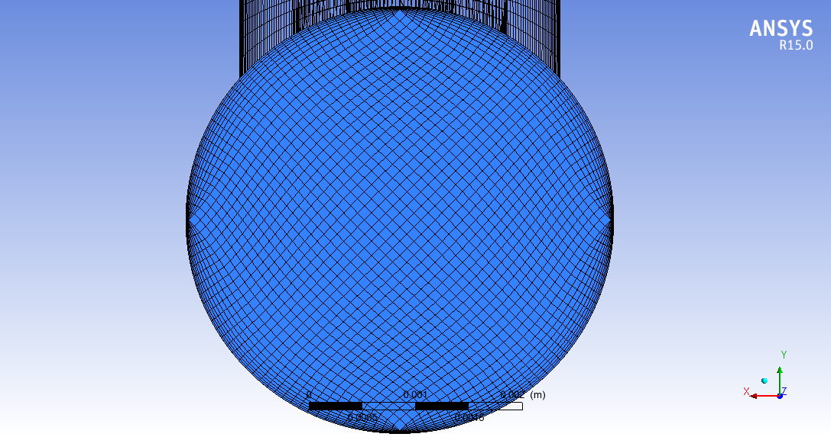

View of pipe section

**ANSYS Fluent 15.0**

Fluent 15.0 launched and the following steps followed.

In the general settings, the default values kept, like, Mesh check and scaling. The solver type was taken as pressure based, steady state and absolute velocity formulation

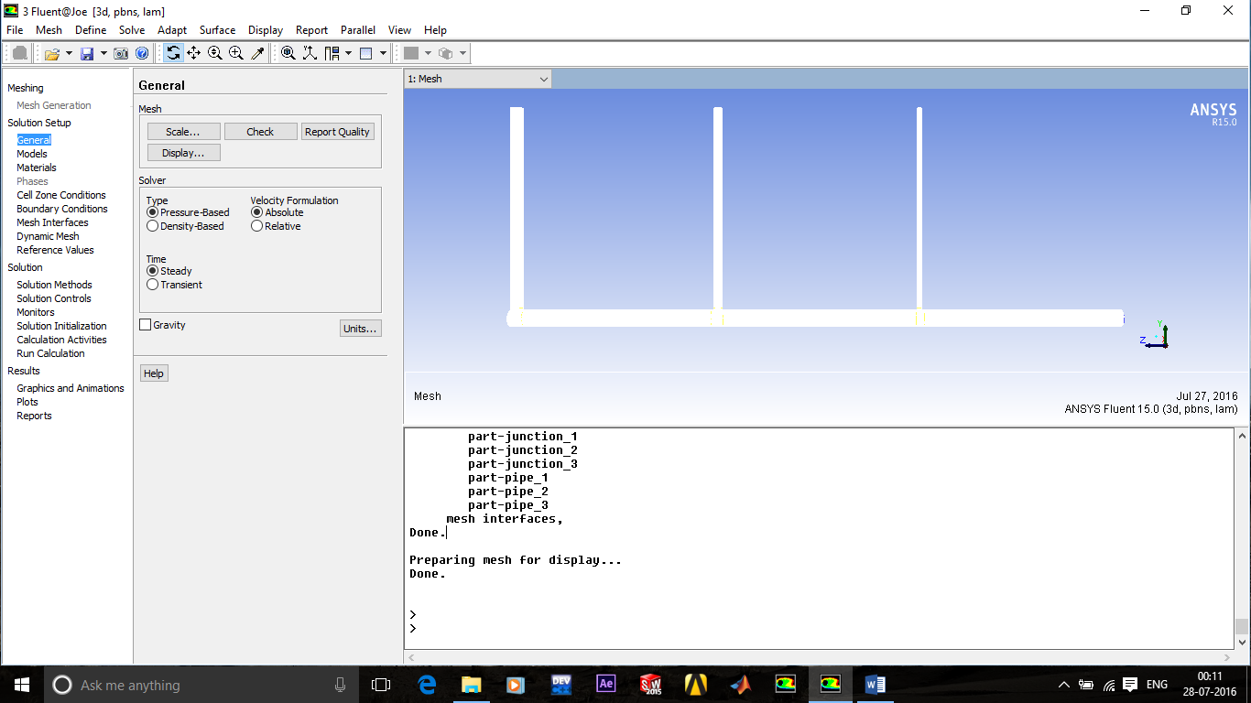

View of pipe mesh opened in ANSYS FLUENT along with all the Solution setup parameters.

Now the Models settings were opened and the following models were checked:

* Invisicd (for Invisicd),
* Laminar (for free-slip and no-slip).

Then the Materials were defined. Fluid was defined as the given oil (SAE 30W) and the known temperature. The default solid material was maintained.

Then the Cell Zones Conditions were defined. The cell zones are the solid bodies that Fluent detects. We had 12 solid part. Each were now defined as fluid domains.

The boundary conditions were given as follows:

|  |  |  |  |
| --- | --- | --- | --- |
| **Name** | **Description** | **Boundary Condition** | **Value (property)** |
| inlet | Inlet | Pressure inlet | 490341.512346 |
| p1_out | Pipe 1 out | Interface | - |
| p2_in | Pipe 2 in | Interface | - |
| p2_out | Pipe 2 out | Interface | - |
| p3_in | Pipe 3 in | Interface | - |
| p3_out | Pipe 3 out | Interface | - |
| j1_in | Junction 1 in | Interface | - |
| j1_out | Junction 1 out | Interface | - |
| j2_in | Junction 2 in | Interface | - |
| j2_out | Junction 2 out | Interface | - |
| j3_in | Junction 3 in | Interface | - |
| b1_in | Junction 1 to Branch 1 | Interface | - |
| b2_in | Junction 2 to Branch 2 | Interface | - |
| b3_in | Junction 3 to Branch 3 | Interface | - |
| h1_in | Branch 1 in | Interface | - |
| h1_out | Branch 1 out | Interface | - |
| h2_in | Branch 2 in | Interface | - |
| h2_out | Branch 2 out | Interface | - |
| h3_in | Branch 3 in | Interface | - |
| h3_out | Branch 3 out | Interface | - |
| Jet_1_in | - | Interface | - |
| Jet_1_out | - | Pressure outlet | 101325 |
| Jet_2_in | - | Interface | - |
| Jet_2_out | - | Pressure outlet | 101325 |
| Jet_3_in | - | Interface | - |
| Jet_3_out | - | Pressure outlet | 101325 |
| Pipe Walls | All curved surfaces on the body, which represent the walls of the pipeline | Wall | (-, Shear=0 & No-Slip) |

Here, the wall conditions are taken as:

NULL; for Invisicd,

Shear=0; for Free- Slip(No Major losses)

No-Slip; for Viscous flow.

The following Mesh interfaces was created in the Fluent

|  |  |  |  |
| --- | --- | --- | --- |
| **Interface** | **Boundary 1** | **Boundary 2** | **Loss to be observed** |
| jet-1 | p1_out | j1_in | Major |
| jet-2 | p2_in | j1_out | Minor (in-line) |
| jet-3 | p2_out | j2_in | Major |
| junction-1-b | p3_in | j2_out | Minor (in-line) |
| junction-1-in | p3_out | j3_in | Major |
| junction-1-out | b1_in | h1_in | Minor (Branch) |
| junction-2-b | b2_in | h2_in | Minor (Branch) |
| junction-2-in | b3_in | h3_in | Minor (Branch) |
| junction-2-out | h1_out | Jet_1_in | Major + Minor (Exit) |
| junction-3-b | h2_out | Jet_2_in | Major + Minor (Exit) |
| junction-3-in | h3_out | Jet_3_in | Major + Minor (Exit) |

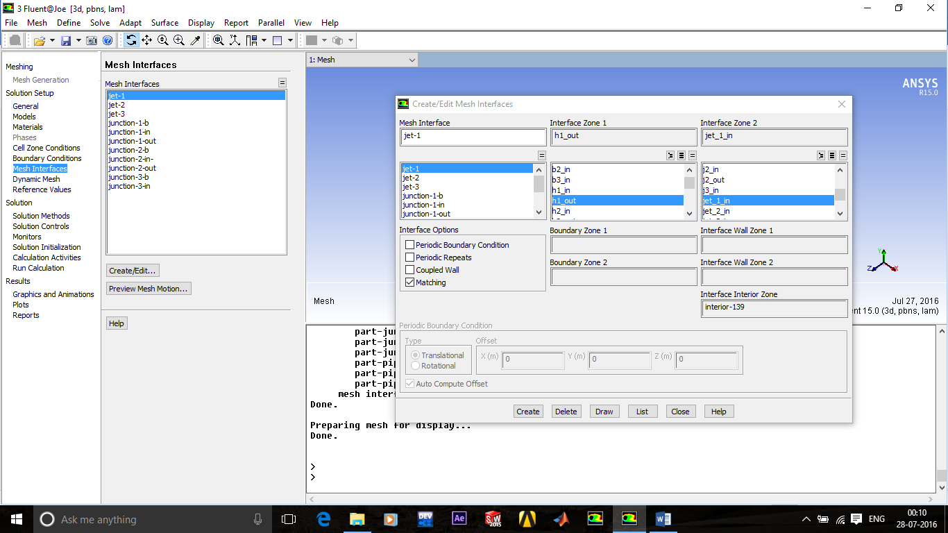

Screenshot of mesh interfaces being created in ANSYS FLUENT along with their respective mesh boundary walls

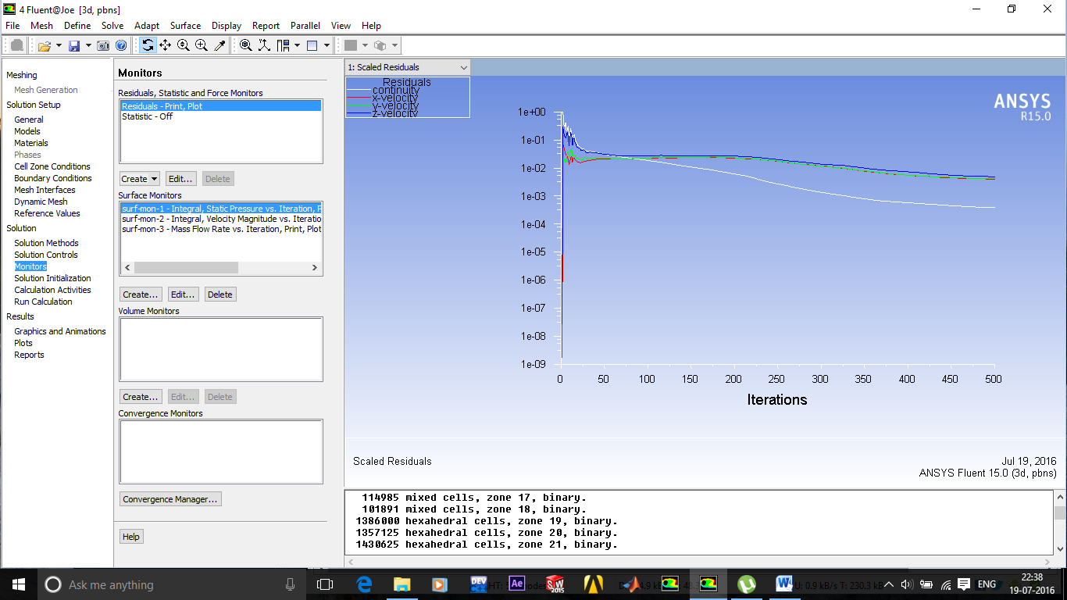

Screenshot of solution Residuals being tabulated in the solution in ANSYS FLUENT along with all the Solution monitors setup up for the same.

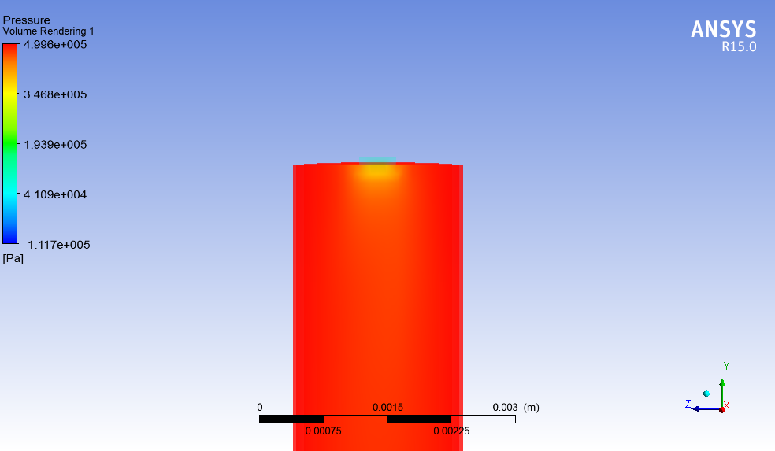

Sectional view of Volume rendering of Pressure at jet 1

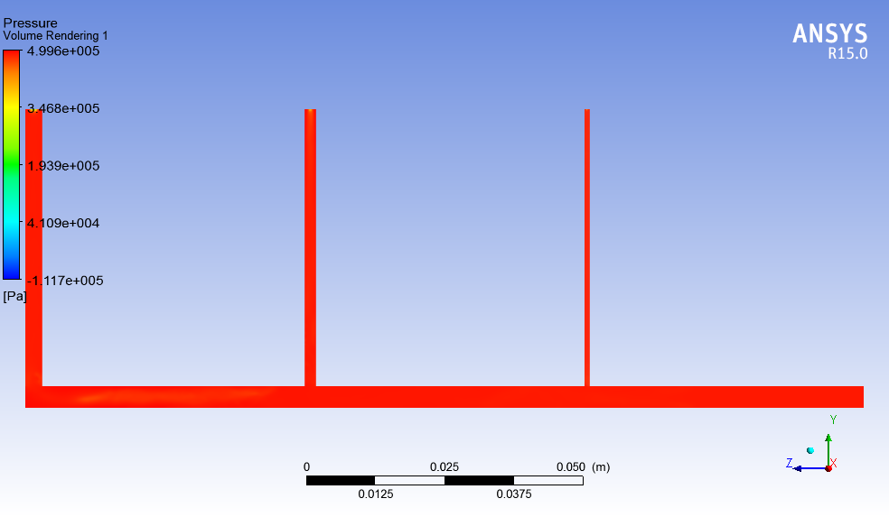

Sectional view of Volume rendering of Pressure throughout the pipeline

**Results**

The tabulation and calculations of the assumed constants and variables was done on MS Excel 2007. The solution was also computed by using the formulas in a loop and randomly iterated (repeated) multiple times and convergence check was done using the convergence criteria on a cell to return Converged YES or Converged NO. The iterations were stopped as the convergence was met.

The following are the final tabulated results for the various cases.

Velocity in (m/s)

Flow Rate in (ml/min)

|  |  |  |
| --- | --- | --- |
| **Results** | | |
| **Cross Section** | **Velocity** | **Flow Rate** |
| **Jet 1** | 29.550182 | 111.525497 |
| **Jet 2** | 29.550182 | 320.836500 |
| **Jet 3** | 29.550182 | 1809.718384 |
| **Inlet** | 2.973651 | 2242.080381 |

|  |  |  |
| --- | --- | --- |
| **Results** | | |
| **Cross Section** | **Velocity** | **Flow Rate** |
| **Jet 1** | 29.230790 | 110.320076 |
| **Jet 2** | 28.907869 | 313.862680 |
| **Jet 3** | 28.581299 | 1750.381848 |
| **Inlet** | 2.884106 | 2174.564604 |

|  |  |  |
| --- | --- | --- |
| **Results** | | |
| **Cross Section** | **Velocity** | **Flow Rate** |
| **Jet 1** | 29.230057 | 110.317311 |
| **Jet 2** | 28.922857 | 314.025409 |
| **Jet 3** | 28.659696 | 1755.183045 |
| **Inlet** | 2.890686 | 2179.525765 |

|  |  |  |
| --- | --- | --- |
| **Results** | | |
| **Cross Section** | **Velocity** | **Flow Rate** |
| **Jet 1** | 29.645412 | 111.884903 |
| **Jet 2** | 29.599325 | 321.370058 |
| **Jet 3** | 29.863166 | 1828.886212 |
| **Inlet** | 3.000258 | 2262.141172 |

|  |  |  |
| --- | --- | --- |
| **Results** | | |
| **Cross Section** | **Velocity** | **Flow Rate** |
| **Jet 1** | 23.843026 | 89.986088 |
| **Jet 2** | 27.849812 | 302.374999 |
| **Jet 3** | 28.382995 | 1738.237286 |
| **Inlet** | 2.825794 | 2130.598373 |

|  |  |  |
| --- | --- | --- |
| **Results** | | |
| **Cross Section** | **Velocity** | **Flow Rate** |
| **Jet 1** | 21.593109 | 81.494667 |
| **Jet 2** | 23.849014 | 258.936954 |
| **Jet 3** | 24.471895 | 1498.712860 |
| **Inlet** | 2.439241 | 1839.144481 |

|  |  |  |
| --- | --- | --- |
| **Results** | | |
| **Cross Section** | **Velocity** | **Flow Rate** |
| **Jet 1** | 1.334056 | 5.034868 |
| **Jet 2** | 2.000130 | 21.716098 |
| **Jet 3** | 3.210953 | 196.645855 |
| **Inlet** | 0.296289 | 223.396821 |

|  |  |  |
| --- | --- | --- |
| **Results** | | |
| **Cross Section** | **Velocity** | **Flow Rate** |
| **Jet 1** | 16.396138 | 61.880750 |
| **Jet 2** | 17.931453 | 194.687953 |
| **Jet 3** | 19.233337 | 1177.891993 |
| **Inlet** | 1.902513 | 1434.460695 |

**ANALYTICAL RESULTS (from Case 8)**

|  |  |  |
| --- | --- | --- |
| **Inviscid** | | |
| **Boundary** | **Static Pressure (Pa)** | **Velocity (m/s)** |
| Inlet | 490341.5123 | 2.103680686 |
| Pipe 1 out | 490341.5123 | 2.103680686 |
| Pipe 2 in | 475947.7886 | 1.999045664 |
| Pipe 2 out | 465562.3352 | 1.999045664 |
| Pipe 3 in | 480197.8981 | 1.69804371 |
| Pipe 3 out | 466788.1463 | 1.69804371 |
| Branch 1 in | 458953.4103 | 1.674160355 |
| Branch 2 in | 285529.223 | 1.204007818 |
| Branch 3 in | 272135.0325 | 3.018744372 |
| Branch 1 out | 264253.389 | 1.674160355 |
| Branch 2 out | 475947.7886 | 1.204007818 |
| Branch 3 out | 465562.3352 | 3.018744372 |
| Jet out 1 | 101325 | 20.90374902 |
| Jet out 2 | 101325 | 20.9029135 |
| Jet out 3 | 101325 | 20.90543194 |
| **Mass Flow Rate** | | |
| **Boundary** | **Kg/s** | **ml/min** |
| Jet 1 | 0.00117156 | 78.89294808 |
| Jet 2 | 0.003370209 | 226.9501269 |
| Jet 3 | 0.019012378 | 1280.294794 |
| Inlet | 0.023554147 | 1586.137869 |

|  |  |  |
| --- | --- | --- |
| **Viscous Free Slip** | | |
| **Boundary** | **Static Pressure (Pa)** | **Velocity (m/s)** |
| Inlet | 490341.5123 | 1.949692401 |
| Pipe 1 out | 490341.5123 | 1.949692401 |
| Pipe 2 in | 476452.4964 | 1.865620338 |
| Pipe 2 out | 466050.1101 | 1.865620338 |
| Pipe 3 in | 467493.2912 | 1.601762664 |
| Pipe 3 out | 461711.8874 | 1.601762664 |
| Branch 1 in | 456298.4783 | 1.345152994 |
| Branch 2 in | 204129.9684 | 1.055430699 |
| Branch 3 in | 223572.4541 | 2.847578069 |
| Branch 1 out | 242919.8542 | 1.345152994 |
| Branch 2 out | 476452.4964 | 1.055430699 |
| Branch 3 out | 466050.1101 | 2.847578069 |
| Jet out 1 | 101325 | 16.79572718 |
| Jet out 2 | 101325 | 18.32344964 |
| Jet out 3 | 101325 | 19.72006973 |
| **Mass Flow Rate** | | |
| **Boundary** | **Kg/s** | **ml/min** |
| Jet 1 | 0.000941324 | 63.38884148 |
| Jet 2 | 0.002954318 | 198.9439998 |
| Jet 3 | 0.017934354 | 1207.700596 |
| Inlet | 0.021829997 | 1470.033437 |

|  |  |  |
| --- | --- | --- |
| **Viscous No Slip** | | |
| **Boundary** | **Static Pressure (Pa)** | **Velocity (m/s)** |
| Inlet | 490341.5123 | 1.902512586 |
| Pipe 1 out | 484824.2258 | 1.902512586 |
| Pipe 2 in | 466288.5239 | 1.820440693 |
| Pipe 2 out | 451834.8902 | 1.820440693 |
| Pipe 3 in | 462734.6386 | 1.562227776 |
| Pipe 3 out | 452093.4054 | 1.562227776 |
| Branch 1 in | 442465.515 | 1.313150289 |
| Branch 2 in | 198981.6976 | 1.032851668 |
| Branch 3 in | 218390.4619 | 2.777293823 |
| Branch 1 out | 235914.2106 | 1.313150289 |
| Branch 2 out | 471567.8019 | 1.032851668 |
| Branch 3 out | 456365.3508 | 2.777293823 |
| Jet out 1 | 101325 | 16.39613791 |
| Jet out 2 | 101325 | 17.93145256 |
| Jet out 3 | 101325 | 19.23333673 |
| **Mass Flow Rate** | | |
| **Boundary** | **Kg/s** | **ml/min** |
| Jet 1 | 0.000918929 | 61.88074953 |
| Jet 2 | 0.002891116 | 194.6879527 |
| Jet 3 | 0.017491696 | 1177.891993 |
| Inlet | 0.021301741 | 1434.460695 |

**MATLAB RESULTS (using Newton-Raphson method)**

|  |  |  |
| --- | --- | --- |
| **Invisicd** | | |
| **Cross Section** | **Velocity** | **Flow Rate** |
| **Inlet** | 2.046286082275070 | **1542.863357572420000** |
| **Branch 1** | 0.825477816658564 | 38.899725667738300 |
| **Branch 2** | 0.783268677406377 | 147.642667363612000 |
| **Branch 3** | 0.663982672531276 | 281.605016628248000 |
| **Jet 1** | 20.903285446124700 | **78.891198518794200** |
| **Jet 2** | 20.534680260009400 | **222.952091841772000** |
| **Jet 3** | 20.264130314250800 | **1241.020067211850000** |

|  |  |  |
| --- | --- | --- |
| **Free Slip** | | |
| **Cross Section** | **Velocity** | **Flow Rate** |
| **Inlet** | 1.899490105687490 | **1432.181798782640000** |
| **Branch 1** | 0.205727738768775 | 9.694691291334350 |
| **Branch 2** | 0.325179471981318 | 61.294886416483000 |
| **Branch 3** | 0.326009598200730 | 138.265563425468000 |
| **Jet 1** | 16.795676712727200 | **63.388650995382200** |
| **Jet 2** | 18.005217813560700 | **195.488847392370000** |
| **Jet 3** | 19.158426096114100 | **1173.304300394890000** |

|  |  |  |
| --- | --- | --- |
| **Laminar** | | |
| **Cross Section** | **Velocity** | **Flow Rate** |
| **Inlet** | 1.856820747854560 | **1400.009860918320000** |
| **Branch 1** | 0.197179375126399 | 9.291859145047820 |
| **Branch 2** | 0.313049455461404 | 59.008432169269900 |
| **Branch 3** | 0.314376539213893 | 133.331808517472000 |
| **Jet 1** | 16.410988865756400 | **61.936798587713500** |
| **Jet 2** | 17.633236306907400 | **191.450116134581000** |
| **Jet 3** | 18.722756719984500 | **1146.622946196020000** |

**MATLAB RESULTS 2 (using Root method, as in Case 8)**

|  |  |  |
| --- | --- | --- |
| **Invisicd** | | |
| **Cross Section** | **Velocity** | **Flow Rate** |
| **Inlet** | 2.046286082083090 | **1542.863357427670000** |
| **Branch 1** | 0.825477816581118 | 38.899725664088700 |
| **Branch 2** | 0.783268677328882 | 147.642667349005000 |
| **Branch 3** | 0.663982672460392 | 281.605016598186000 |
| **Jet 1** | 20.903285446148900 | **78.891198518885500** |
| **Jet 2** | 20.534680258870500 | **222.952091829407000** |
| **Jet 3** | 20.264130312087600 | **1241.020067079370000** |

|  |  |  |
| --- | --- | --- |
| **Free Slip** | | |
| **Cross Section** | **Velocity** | **Flow Rate** |
| **Inlet** | 1.899490108445870 | **1432.181800862410000** |
| **Branch 1** | 0.205727739326103 | 9.694691317597820 |
| **Branch 2** | 0.325179472806807 | 61.294886572084000 |
| **Branch 3** | 0.326009599033854 | 138.265563778809000 |
| **Jet 1** | 16.795676712684800 | **63.388650995222100** |
| **Jet 2** | 18.005217829806400 | **195.488847568755000** |
| **Jet 3** | 19.158426127196300 | **1173.304302298430000** |

|  |  |  |
| --- | --- | --- |
| **Laminar** | | |
| **Cross Section** | **Velocity** | **Flow Rate** |
| **Inlet** | 1.856820748086220 | **1400.009861092990000** |
| **Branch 1** | 0.197179375172412 | 9.291859147216130 |
| **Branch 2** | 0.313049455528810 | 59.008432181975600 |
| **Branch 3** | 0.314376539281011 | 133.331808545938000 |
| **Jet 1** | 16.410988866568700 | **61.936798590779200** |
| **Jet 2** | 17.633236308478800 | **191.450116151642000** |
| **Jet 3** | 18.722756722508000 | **1146.622946350560000** |

**CFD RESULTS**

|  |  |  |
| --- | --- | --- |
| **Inviscid** | | |
| **Boundary** | **Static Pressure (Pa)** | **Velocity (m/s)** |
| Inlet | 488409.69 | 2.107784 |
| Pipe 1 out | 487597.78 | 2.5974474 |
| Pipe 2 in | 487726.31 | 2.3237939 |
| Pipe 2 out | 489587.97 | 2.0939472 |
| Pipe 3 in | 490101.34 | 1.7203451 |
| Pipe 3 out | 491115.09 | 2.937572 |
| Branch 1 in | 482692.88 | 2.2618475 |
| Branch 2 in | 487512.53 | 1.8880905 |
| Branch 3 in | 485042.66 | 3.7138145 |
| Branch 1 out | 260698.34 | 15.524673 |
| Branch 2 out | 209645.11 | 20.891785 |
| Branch 3 out | 233720.47 | 21.478086 |
| Jet out 1 | 100952.76 | 21.215185 |
| Jet out 2 | 101325.24 | 25.178009 |
| Jet out 3 | 101042.16 | 22.434687 |
| **Mass Flow Rate** | | |
| **Boundary** | **Kg/s** | **ml/min** |
| Jet 1 | 0.001147262 | 77.25670707 |
| Jet 2 | 0.003557 | 239.5310707 |
| Jet 3 | 0.018458 | 1242.976229 |
| Inlet | 0.023655 | 1592.907138 |

|  |  |  |
| --- | --- | --- |
| **Viscous Free Slip** | | |
| **Boundary** | **Static Pressure (Pa)** | **Velocity (m/s)** |
| Inlet | 488574.13 | 1.9862853 |
| Pipe 1 out | 496519.09 | 4.0012746 |
| Pipe 2 in | 500621.75 | 3.6205759 |
| Pipe 2 out | 522846.53 | 4.4533892 |
| Pipe 3 in | 531266.44 | 3.6210549 |
| Pipe 3 out | 578800.69 | 3.9587526 |
| Branch 1 in | 475191.22 | 6.8775411 |
| Branch 2 in | 507562.31 | 6.432972 |
| Branch 3 in | 568391.19 | 5.4960899 |
| Branch 1 out | 192353.94 | 15.205604 |
| Branch 2 out | 214669.16 | 20.695024 |
| Branch 3 out | 200035.23 | 25.691082 |
| Jet out 1 | 101324.97 | 18.304613 |
| Jet out 2 | 101277.18 | 22.262001 |
| Jet out 3 | 101039.64 | 25.952002 |
| **Mass Flow Rate** | | |
| **Boundary** | **Kg/s** | **ml/min** |
| Jet 1 | 0.00094399 | 63.56834747 |
| Jet 2 | 0.003026 | 203.7961616 |
| Jet 3 | 0.018272 | 1230.458519 |
| Inlet | 0.022233 | 1497.1967 |

|  |  |  |
| --- | --- | --- |
| **Viscous No Slip** | | |
| **Boundary** | **Static Pressure (Pa)** | **Velocity (m/s)** |
| Inlet | 488546.53 | 1.9693359 |
| Pipe 1 out | 479461.09 | 1.9950666 |
| Pipe 2 in | 479368.69 | 1.9095106 |
| Pipe 2 out | 473112.78 | 1.8855526 |
| Pipe 3 in | 473691.28 | 1.6149395 |
| Pipe 3 out | 468554.34 | 1.6688484 |
| Branch 1 in | 476727.75 | 1.3623226 |
| Branch 2 in | 471692.28 | 1.1509067 |
| Branch 3 in | 462030.72 | 3.1367819 |
| Branch 1 out | 253667.34 | 12.858975 |
| Branch 2 out | 255573 | 16.588364 |
| Branch 3 out | 212849.98 | 20.508772 |
| Jet out 1 | 101324.97 | 16.907021 |
| Jet out 2 | 101325.24 | 18.871626 |
| Jet out 3 | 101319.06 | 21.018332 |
| **Mass Flow Rate** | | |
| **Boundary** | **Kg/s** | **ml/min** |
| Jet 1 | 0.000939077 | 63.23752391 |
| Jet 2 | 0.003025 | 203.696101 |
| Jet 3 | 0.017948 | 1208.63697 |
| Inlet | 0.022030 | 1483.487475 |

**Conclusions**

The relative errors can be easily visualised by the graphs represented below.

Now, the plot of the errors between each method is given below and the variation was studied for each condition (Inviscid and Viscous).

The variation or errors in the flow rates can be observed to increase alone the pipeline. This implies that due to the 3D model, the junction imposes unpredictable losses in the branching as well as the in line flow. If we observe the graphs carefully and as we know the in line flow exists after the first jet and second jet but not after the third jet, the error is greater at the second jet than the third jet. This verifies that there exists a significant error only in the in-line minor losses. The major losses are giving an overall error in the flow as seen by comparing viscous free slip and no slip.

Hence, the relative errors are not more than approximately 7%. This shows that we have successfully modelled the problem theoretically and solved it analytically as well as experimentally (CFD was taken as experimental results)

**References**

Handbook: “Introduction to practical fluid flow” R.P King, University of Utah.

Literature: “Fluid Mechanics” Frank M. White, University of Rhode Island.

Matlab 2010b.

ANSYS Fluent 15

Solidworks 2015